First-Year Engineering at The University of Alabama
http://www.foundationcoalition.org

Student Quotes
“I like the structure of the curriculum and the way the classes are taught. I like the idea of working in groups to solve projects in the manner that I would see them in the real world. This gives me a good idea of what life will be like once I enter the job market.”
“I have enjoyed being in this program very much. I am learning valuable teamwork skills as well as problem solving strategies and engineering principles.”
“The main thing that I enjoy is the friends that you make … it is like we are one big family. I couldn't imagine the transition to college being any easier than it has been.”

TIDE (Teaming, Integration, Design and Engineering)
The TIDE (Teaming, Integration, Design and Engineering) program at the University of Alabama was developed from a Foundation Coalition pilot curriculum that was first offered in the 1994-95 academic year. TIDE is the freshman program that has been offered to engineering students since fall 1999. In the current configuration, students participating in TIDE work side-by-side with other students, teaching assistants and faculty to learn five core subjects during their first few semesters: Mathematics, Chemistry, Physics, Engineering and English. The development of teaming skills, computer skills, and communication skills through engineering design projects are key features of the TIDE program, as are curriculum integration between math and engineering, and between math and physics.
TIDE Structure
About 400 students per year enter the College of Engineering at The University of Alabama with a wide variety of backgrounds, particularly in mathematics. As shown in the figure below, the largest single group consists of calculus-ready students, but a large number of students enter one of the two pre-calculus tracks.

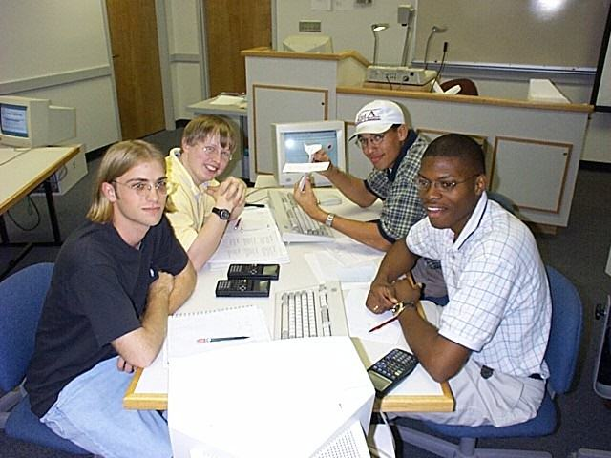

Benefits of TIDE
The TIDE and FC programs have been in development at UA since 1994, and data gathered indicates three primary benefits that are realized by students participating in the program:
- Increased student retention in the College of Engineering (COE) and at UA
- Enhanced sense of community and belonging by the students
- Improved introduction to the discipline of engineering

Improved Retention
The graph on the left compares retention of the cohort of students who participated in the Foundation Coalition pilot curriculum in the 1995-96 academic year with that of a carefully matched cohort of students who participated in the traditional, first-year engineering curriculum in the same academic year. Four years later about 70% of the Foundation Coalition cohort was still enrolled in engineering compared with 50% of the traditional cohort. Similar results have been observed in more recent years.

Other Features of TIDE
- Students attend core classes in “cohorts” of 20 students during their first semester at UA. This helps them to get to know other engineering students quickly, producing a small school atmosphere.
- Faculty and teaching assistants from the core subjects meet regularly to integrate course topics. This helps students see the links between the core subjects.
- Students work on engineering design projects as freshmen. This helps students choose their correct career path early.

Teaming and Design Projects  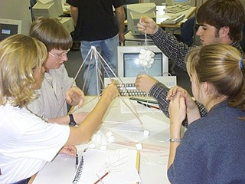  In the TIDE program, students begin to interact with their fellow classmates and engineering faculty from the beginning of their college career. Students get an immediate exposure to the discipline of engineering. As an integral part of their freshman year, students work in teams on engineering design projects that utilize the materials being presented in mathematics and the sciences. This gives students immediate experience to the issues and problems that working engineers confront.  Typical TIDE Design Projects:  - CNG Tank for Alternatively Fueled Vehicle  - Stream Pollution Remediation  - Power Distribution for Residential Subdivision  - Balance Beam for Gymnastics  - Parking Lot Optimization | Three Paths through TIDE  The table below shows the three primary entry points into the TIDE program. The actual combination of TIDE courses that a student takes depends greatly on their entering math placement. The TIDE program is designed to give each student the largest possible exposure to the integrated courses while recognizing the needs of students with different backgrounds. Transfer students and students that enter with AP credit in Calculus are also accommodated by the TIDE program.
References for Further Information
- Cordes, D., J. Parker, J. Richardson, and C. Haynes, Institutionalizing a Prototype Freshman Year – Alabama’s TIDE Program, Proceedings of the 2000 ASEE Southeastern Section Conference, Roanoke, VA, April 2-4, 2000
- Frair, K., Curriculum Integration at the University of Alabama, Proceedings of the Frontiers in Education 25th Annual Conference, Atlanta, GA, November, 1995
- Frair, K., An Integrated First-Year Curriculum: The Foundation Coalition and The University of Alabama," Proceedings of the Frontiers in Education 24th Annual Conference, San Jose, CA, November 1994
- Parker, J., J. Richardson, D. Cordes, The Foundation Coalition Freshman Year: Lessons Learned, Proceedings of the Frontiers in Education 26th Annual Conference, Salt Lake City, UT, November, 1996
- Parker, J., J. Richardson, and D. Cordes, Problem Solving and Design in the Freshman Year: The Foundation Coalition, Proceedings of the 1996 ASEE Southeastern Section Conference, Gatlinburg, TN, April, 1996
- Parker, J., D. Cordes, C. Laurie, A. Hopenwasser, J. Izatt, and D. Nikles, Curriculum Integration in the Freshman Year at The University of Alabama - Foundation Coalition Program, Proceedings of the Frontiers in Education 25th Annual Conference, Atlanta, GA, November, 1995
- Parker, J., D. Cordes, J. Richardson, Engineering Design in the Freshman Year at The University of Alabama - Foundation Coalition Program, Proceedings of the Frontiers in Education 25th Annual Conference, Atlanta, GA, November, 1995.
For additional information on TIDE at The University of Alabama please see:
http://tide.eng.ua.edu
Whether you're just getting started or looking for some additional ideas, the Foundation Coalition would like to help you improve integration across your engineering classes through workshops, web sites, lesson plans, and reading materials. For suggestions on where to start, see our web site at http://www.foundationcoalition.org or contact: Jeffrey Froyd at froyd@ee.tamu.edu or 979-845-7574.

