Introduction to the Foundation Coalition
http://www.foundationcoalition.org

The Foundation Coalition (FC), one of eight engineering coalitions funded by the National Science Foundation, was established as an agent of systemic renewal for the engineering educational community. FC partner campuses have restructured their curricula, renovated or built new classrooms, and created faculty development projects guided by seven ideas (listed below) that are informed by a number of theories that address learning and change. Two of the theoretical frameworks used are social learning theory and constructivist learning theory. Most projects have focused on the first two years, the foundational years, of the engineering curricula.
- Active/cooperative learning: increasing student participation in and ownership of their learning
- Increasing the participation of women and underrepresented minorities in engineering: if the learning environment works for a more diverse student body, then it will be a better learning environment for all students
- Student teams in engineering: helping students develop their abilities to work within and lead teams which requires more than assigning students to group projects
- Technology-enabled learning: creating learning environments in which routine access to ubiquitous technology is assumed and the revision of learning activities based on this assumption
- Continuous improvement through assessment, evaluation and feedback: develop assessment processes to collect data on the impact of changes to the curricula and learning environments, reaching conclusions about the efficacy of those changes, and making improvements where indicated
- Curriculum integration and inclusive learning communities: helping students make connections between various disciplines and between academic topics and lifelong careers and helping them to build learning relationships with other students
- Organizational development and change: making significant curricular changes requires a complex, thoughtful change model that is based on research and experience

Partner institutions have built or remodeled numerous
FC Classrooms
that facilitate cooperative learning, student teams, routine technology use, and discovery of connections across disciplines.

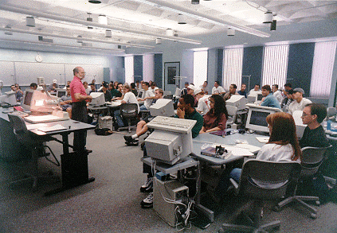
Why might you be interested in the Foundation Coalition (FC)?
If you are working on:
- Curriculum renewal
- Technology in the classroom
- Assessment tools and processes, e.g., EC 2000 accreditation
- Integrated curricula
- Learning communities
- New pedagogies, e. g., active/cooperative learning and/or teaming
We can provide:
- Over 15 different workshops on a variety of topics
- Restructured curricula
- Classroom designs
- Course materials
- Ideas and experience

FC Partner Institutions
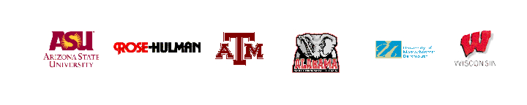

University of Alabama
Entering Engineering Student Body: 400 students
University of Alabama offers its new program, TIDE (Team-based Introduction to Design and Engineering), to all first-year students. The program was phased in over a three-year period. TIDE students attend chemistry lab, English and math recitations in 20-student cohorts. Two cohort groups are combined for math and engineering lectures and eight cohort groups are combined for chemistry lecture. TIDE contains two tracks: calculus-ready and pre-calculus. The TIDE core classes extend through all three semesters of calculus.
UA has also developed a multidisciplinary course on the applications of signal and network analysis for upper division students. A college-wide faculty development program is in place to help faculty remain abreast of developments in engineering education. Recent work includes the development of several course modules targeting EC2000 outcomes and concept inventories for strength of materials and thermodynamics.
Arizona State University
Entering Engineering Student Body: 900 students
ASU implemented a first-year curriculum that integrated engineering, English, physics and mathematics for the 80 students qualified to participate. They also extended innovative pedagogies such as cooperative learning, integrated curricula and learning communities to a much larger percentage of their student body, including commuter students, through EnGAGE (Engineering Groups for Academic Growth and Excellence). Each participating first-year student is placed into a cohort of 18-25 students and takes common sections of two of three courses required for engineering majors. By fall semester 2001, over 60% of the entering engineering students are participating in EnGAGE. Students taking physics at ASU have also demonstrated impressive improvements in scores on the Force Concept Inventory (FCI) through the use of new pedagogical practices. Further, changes in pedagogical practice can be monitored through the Reformed Teaching Observation Protocol (RTOP). Faculty members at ASU have also developed an integrated course sequence in electromagnetics and electronic materials. Simultaneously, they have also constructed a Wave Concept Inventory (WCI) to measure improvements in student learning of the concepts in the integrated course.

University of Massachusetts-Dartmouth
Entering Engineering Student Body: 200 students
The University of Massachusetts-Dartmouth (UMD) set a speed record for institutionalization when they offered their IMPULSE (Integrated Mathematics, Physics, Undergraduate Laboratory Science and Engineering) program to all first-year students in fall semester 1999, after only one year of piloting. IMPULSE students take tightly integrated calculus, physics and engineering science courses and also participate in separate chemistry and English courses. In addition to enrollment in common course sections, entering students who participate in a cohorted learning community reside in a common dorm to improve the sense of community. Faculty members at UMD have also developed concept inventories for signal and systems and electromagnetics and processes for embedding assessment in the classroom.

Rose-Hulman Institute of Technology
Entering Engineering Student Body: 400 students
Rose-Hulman developed and institutionalized a Sophomore Engineering Curriculum (SEC) to integrate engineering science and mathematics. It is currently required for all electrical engineering, computer engineering, and mechanical engineering majors. All engineering science courses and two of the mathematics courses are block scheduled so that each cohort of students is enrolled in the same course sections. Each year there have been seven cohorts of about thirty students each quarter. Each cohort is a randomly mixed and balanced group of electrical, computer, and mechanical engineering students. At the upper division, the Electrical and Computer Engineering Department completely restructured its junior and senior curricula to provide an industry-sponsored design experience and a more thoroughly integrated learning experience for its students.

University of Wisconsin-Madison
Entering Engineering Student Body: 800 students
Building on efforts at other Foundation Coalition schools, UW, a new partner, initiated its LINKS curriculum in fall semester 1999. Now, first-year students may participate in many opportunities built on FC theories. Engineering freshmen take may take chemistry and mathematics linked by common discussion sections. Students taking a required communication course may link that course with a first-year design course, an introduction to the engineering profession, an ethics course or one of several research seminars. One of the most successful links has been that between the required communication course and a new ethics course. The linked courses are team taught by faculty with expertise in communication and ethics and communication faculty members were also trained in the teaching of ethics. This link will be expanded in the future. In the design course, design teams were found to be formed more readily and to interact more effectively than those in the non-linked courses. Faculty found that students highly valued the learning communities formed by the linked courses for both social and academic reasons.

Texas A&M University
Entering Engineering Student Body: 1800 students
All lower-division engineering students at Texas A&M University, 1800 freshmen and 1500 sophomores, participate in curricula restructured along FC theories and participate in diverse learning communities. Industry sponsors present real-life case studies to students to simulate the real drama of engineering problem solving. Diversity in the workplace is demonstrated by the composition of the engineering teams and through professional workshops in which students discuss the added value of a diverse workforce. Industry sponsors also emphasize the value of teamwork and effective communication in engineering problem solving and design. The sophomore engineering science curriculum uses a conservation and accounting framework to unify the diverse engineering sciences: circuits, fluid mechanics, thermodynamics, statics and dynamics. Many students are cohorted within several courses helping them establish a sense of community within this very large engineering college.

Whether you're just getting started or looking for some additional ideas, the Foundation Coalition would like to help you incorporate innovations into your classrooms, curricula and learning environments through workshops, web sites, lesson plans, and reading materials. For suggestions on where to start, see our web site at
http://www.foundationcoalition.org or contact: Jeffrey Froyd at froyd@ee.tamu.edu or 979-845-7574.

