Introduction
Instructors who use teams commonly assign projects or other tasks to teams outside of class. In Foundation Coalition (FC) workshops on teams, one of the more frequently asked questions about teams is how team assignments can be graded. One approach to grading team assignments is to give the same grade to every team member. However, giving every individual the same grade for a team assignment runs counter to the principle of individual accountability in cooperative learning. Further, it may reward and even encourage “hitchhiking” by some members of a team. However, determining individual grades for work products submitted by a team is a challenging task. One approach to obtain information that may be helpful in determining individual grades is peer assessment. To help faculty members in using peer assessment and/or peer evaluation in their classes, the following issues are addressed:

Definition
A team is a small group of people with complementary skills who are committed to a common purpose, performance goals, and an approach for which they hold themselves mutually accountable.¹ Although student teams may not satisfy all the requirements of the definition, the degree to which they do often determines their effectiveness.

Peer Assessment and Peer Evaluation
http://www.foundationcoalition.org

What is it?
Peer assessment or peer evaluation can mean many things—a means of raising the bar by exposing students to exceptionally good (or bad) solutions; peer grading of homework, quizzes, etc.; and an aid to improving team performance or determining individual effort and individual grades on team projects. For the purposes of the present discussion, peer assessment or peer evaluation is a process of using data collected by asking team members to evaluate each team member in assigning individual grades for team assignments. Peer assessment or peer evaluation is not the same as peer grading. Some references to peer grading are provided below.
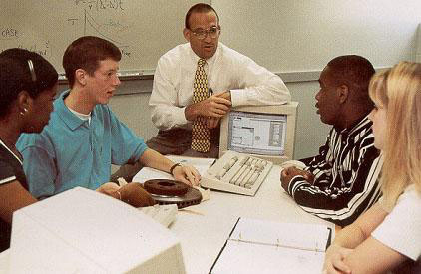

- What is it? Peer assessment allows team members to assess other members of the team as well as themselves. Peer assessment provides data that might be used in assigning individual grades for team assignments.
- Why might I use team assignments? Teams produce higher quality results and can improve learning.
- What are the general issues to consider in using peer assessment? Give students rules the first day, have them assess each other, and provide feedback.
- What is the quality of the evaluations of team members of each other? With practice, students assess each other consistently and fairly.
- What are considerations for team grading? These include signature sheets, workload tables, assessments, evaluations, and bonus points.
- What are examples of what teachers are doing in the classroom? Faculty members describe their peer assessment methods.

What are the general issues to consider in using peer assessment?

Issue 1: Tell them early
Announce rules and format on the first day Many instructors hand out copies of the forms used for assessment and evaluation with (or as a part of) the syllabus.

Issue 2: Give them practice
Do assessment before (it counts) evaluation Students usually have no experience with assessing or evaluating the work of peers (or often even their own work). Provide opportunities for them to assess other team members in situations in which their assessments do not affect project grades.

Issue 3: Include feedback
Allow improvement Most students (given honest feedback from peers) will improve performance and are more willing to give honest feedback to peers as they gain experience with assessment.

Why might I use team assignments?
The reasons for offering team assignments include student, faculty, and learning issues (see other reasons in the Introduction to Teams).

Learning Issues
- Teams come to faculty members with higher-level questions, which implies that they have resolved the lower-level questions
- Research on social dependence supports the assertion that positive interdependent groups produce higher quality results

Student Issues
- Allow students to gain experience working in a team (looks good on a résumé)
- Make students more comfortable with using teams

Faculty Issues
- Make faculty members in subsequent classes less skeptical of student abilities
- Grade fewer (50% to 25%) papers
- Have peers grade with careful guidance some of the above papers (see below)

What is the quality of the evaluations of team members of each other?
Won’t they give everyone the same grade or over-rate their own performance?
Experience indicates that both of these outcomes occur frequently in the first or second cycle of assessment; however, faced with (often unanimous) contrary feedback from their teammates, most students come to a more consistent and reasonable assessment in subsequent cycles. Research also indicates that peer assessment data can be effectively used in assigning individual grades.^{1, 2}
One faculty member reported that the slacker students almost always report themselves as the weakest on the team . . . the difference is whether they contributed 95% (their report) or 50%–75% (the range assigned by their teammates).
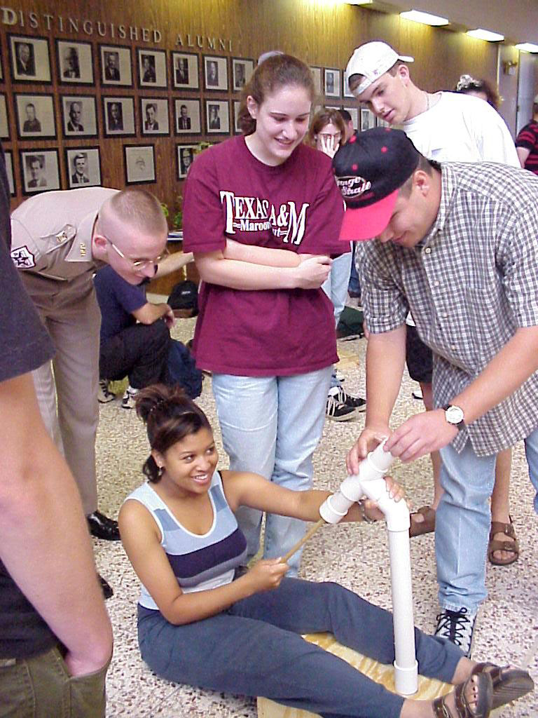
he team.

What are considerations for team grading?
Many tools are available when grading team assignments:
- Signature blocks indicate who contributed to the assignment
- Workload/Percent-effort tables allow grade adjustment and tracking of a team member’s workload
- Peer assessments give students feedback and opportunities to improve performance before grading
- Peer evaluations provide peer ratings of each team member that may serve as a multiplier on the team grade or can determine the team grade
- Bonus points are given to other team members by each member
Combinations of these tools are possible and sometimes desirable. As a general rule instructors may use signature blocks on individual assignments to either give the same grade or a zero. Use other methods to adjust semester or project average for individual performance.

Peer Grading
Those interested in peer grading are referred to Michaelsen and Schultheiss, “Making Feedback Helpful,” The Organizational Behavior Teaching Review, 1988, 13 (1), pp. 109–113.
There have been recent legal challenges to peer grading:
http://www.nea.org/neatoday/0011/rights.html
However, early in 2002 the U.S. Supreme Court overturned this challenge, ruling unanimously for peer grading:
http://www.nassp.org/services/legal_peergrade.html

Calibrated Peer Review (CPR™) provides a creative solution to future court challenges. CPR™ is a program for networked computers that enables peers to anonymously evaluate frequent writing assignments. A calibration cycle normalizes the grading and engages the students to spend more time reading about the topics (and the instructor less time assessing student writing):
http://cpr.molsci.ucla.edu/

Peer Evaluations
- Count peer evaluation as a multiplier on the team grade. Typically, each student on a team of four might receive between 70% and 110% of the team grade (depending on peer evaluation). Brown offers a quantitative algorithm.³
- Normally the team average grade on the assignment remains unchanged (i.e., the faculty member determines the average team member, but the team decides how the individual grades are assigned).
- Assigning individual grades can be done by having students directly assign grades or by using student evaluations of performance to determine individual grades.

Bonus Points
Allow each student to assign a certain number of bonus points (usually 5) with the following restrictions:
- A student can give points to anyone (sometimes limited to members of his/her team but can be anyone in the class, i.e., the person who helped him/her the most)
- Students cannot keep any points for themselves
- Limit the maximum number of bonus points so that the effect on the overall score for each student is restricted.

Assignment Cover Sheets
Faculty members may require that each assignment include cover sheets with either a signature block or a workload table. Both of these indicate the extent to which individual members of the team contributed to the assignment and can be used to determine appropriate individual grades from the team assignment.

Signature Blocks
Team members signing the signature block may receive the same grade, whereas those who do not (or are not allowed to) sign the cover sheet may receive no credit for the assignment. Here are some suggestions:
- Require a signature block on all team assignments. A signature means
I did my share of the work, and I have a general understanding of the contents of the assignment
- Students can decline to sign, or teams can refuse to let a member or members sign
- Students who do not sign the cover sheet receive a grade of zero on the assignment

Workload/Percent-effort Tables
A workload table allows some members of the team to receive a greater (or lesser) share of the credit for the assignment. Some faculty members ask students to list percent effort for each individual, some ask for percent credit, and some ask students to divide the points for the assignment in the workload table. Here are some options:
- Use student-assigned grades or percentages to adjust grades, including the option of a zero for exceptional individual effort. Typically, students are asked to fill in a table on the cover sheet, assigning percentages to each member of their team or distributing available points.
- Often instructors require additional documentation for exceptionally high- (or low-) workload assignments.

Peer Assessments
If you use peer evaluations to provide data for adjusting individual grades, consider using peer assessments so students can practice evaluating team members. Let team members submit ratings of all team members to the faculty member. Then, the faculty member can review the team ratings and provide each student with feedback that can help them improve ratings of their peers. Peer assessments allow the students to gain experience with giving and receiving feedback and give them an opportunity to improve performance before it counts against their grades.

Announce the practices you will use early in the semester, practice them during the semester, and use them to reinforce the importance of individual responsibility to the team.

Example 1: Jim Morgan, Texas A&M University
(Jim-morgan@tamu.edu)
Dr. Morgan assigns individual grades based on team effort in a first-year engineering class of 100 students as described below.
- Use a signature block on all team assignments. A signature means:
I did my share of the work, and I have a general understanding of the contents of the assignment.
Students can decline to sign or teams can refuse to let members sign.
All team members get the same grade on any single assignment, or, if a signature is missing from the assignment, those who do not sign get no credit.
- Use peer assessment (including anonymous feedback) after each month to allow students to see themselves as others see them and to give an opportunity for improved performance.
- Use peer evaluation to adjust semester-average team grades for individual students. The average grade on a team is the grade earned (and given) by the instructor.

References for Further Information
- Kaufman, D.B., Felder, R.M., and Fuller, H. (2000), “Accounting for Individual Effort in Cooperative Learning Teams,” Journal of Engineering Education, 89(2), 133–140.
- Van Duzer, E., and McMartin, F. (1999), “Building Better Teamwork Assessments: A Process for Improving the Validity and Sensitivity of Self/Peer Ratings,” Proceedings, ASEE Conference.
- Brown, R.W. (1995), "Autorating: Getting Individual Marks from Team Marks and Enhancing Teamwork," Proceedings, FIE Conference.
http://www.eas.asu.edu/~asufc/teaminginfo/teams.html
http://www.uoregon.edu/~bartj/pae/peer-eval.html
http://arapaho.nsuok.edu/~legatski/4213Peer.htm
http://iluvatar.lcps.k12.nm.us/manual/eval/peer.html
Whether you are just getting started or looking for additional ideas on peer assessment, peer evaluation, or student teams in general, the Foundation Coalition offers workshops, lesson plans, and reading materials. For suggestions on where to start, see our Web site at http://www.foundationcoalition.org or contact Jeffrey Froyd at froyd@ee.tamu.edu or 979.845.7574.

Example 3: Terry Kohutek, Texas A&M University
(t-kohutek@tamu.edu)
Dr. Kohutek assigns individual grades based on team effort in a first-year engineering class of 100 students as follows:
- Bonus points are distributed to each student at the end of the semester
- A student cannot keep any points
- Points must be distributed in integer amounts
- Points can be given to any student in the class (based on which student most improved his/her performance this semester)
- No student can receive more than 10 points
- Points are applied to the final course grade

Example 4: Russ Pimmel, University of Alabama
(rpimmel@bama.ua.edu)
Dr. Pimmel uses the following process in a senior-level course that includes a monthlong team design project. The course includes several components (essential when using peer evaluation in determining grades):
- Some training in teams (at least 30 minutes discussing team roles, team dynamics, meeting strategies, and so on).
- Required weekly progress reports in which each team member individually answers three multiple-choice questions asking if he/she achieved the week’s goals, spent adequate time, and worked together as a team. Possible answers translate roughly into “yes,” “almost yes,” and “no.” Students are also asked to indicate any particular problem and to identify any noncontributing individual.
- Meetings with teams that are making no progress or having problems, including a noncontributing member.
At the project’s end, each team submits a report, and each student completes an individual quiz and an evaluation form asking him/her to distribute the “effort” among the team members on a percentage basis. Students rate each teammate against the rater’s expectations for that student, taking into account talent, background, and personal situations. The rater is to be fair and honest, not only because it the right thing to do, but also because, when working as professionals, he/she will evaluate peers; this provides practice for this skill. Percentages given to each student are combined to get an effort score.
- Scores are simply averaged, or a “figure-skating” process is used (the highest and the lowest scores are dropped before averaging).
Inconsistent scores are resolved in various ways, based on the professor’s personal knowledge of the students, by talking to them, or by giving everyone an equal-effort score.
From the team report grade, the individual quiz grade, and effort scores, individual report grades and a team quiz grade are computed. The former is obtained by multiplying the team report grade by the individual effort scores and the latter by averaging the individual quiz grades using the effort scores as weighting factors.

Example 2: P. K. Imbrie, Purdue University (imbrie@purdue.edu)
Dr. Imbrie utilizes an automated (Web-based) version of the method described in Example 1 for assigning individual grades based on team effort in first-year engineering classes of 180 to 475 students.
Before students do the peer evaluation that will affect the final grade, they are assigned multiple reflective exercises such as:
- How could you have improved your team’s performance?
- How could others on your team have improved your team’s performance?

What are examples of what teachers are doing in the classroom?
Faculty members have been using the FC assessment and evaluation methods. Here are helpful tips from four of them.

