Why develop student teams?

Improved Learning
Developing team skills while still in college increases students' potential for improved academic performance and simultaneously provides important skills to prepare them for the workplace. Although true for certain traditional team-based courses such as the capstone design course, it is also true on a much wider scale, with today's interest in active learning theories of pedagogy.¹ For example, faculty can effectively use student teams in many other active/cooperative learning activities besides projects.²

Professional Success
Individuals working alone are usually ineffective in solving current, complex engineering problems; instead well-trained multidisciplinary teams can address complex problems more productively. GE, Intel, Motorola, Xerox, Ford, General Motors, and AT&T have all publicly stated their commitment to a team-based work environment. "Graduates of our universities and colleges that can work within team constructs, provide diversity to the brainstorming of problem solutions, and communicate effectively are the most highly sought after engineering talents." [Robert Kern, Raytheon] Recognizing the importance of teams to industry, engineering education has begun to stress this desired student outcome.^{3, 4, 5}

ABET EC 2000 Student Outcomes
Engineering accreditation criteria, EC2000, now state that engineering programs must demonstrate that their graduates have "an ability to function on multi-disciplinary teams."⁶

Group Experiences Do Not Necessarily Develop Team Skills
Placing students in groups may not develop a team. This is seen in the graph from Katzenbach and Smith¹ in which team effectiveness must be developed for performance to equal or exceed that of several individuals working separately. Further, placing students in design teams does not necessary guarantee that students will develop capacities to function on multi-disciplinary teams. As Johnson, Johnson and Holubec assert: "Students do not come to school with the social skills they need to collaborate effectively with others. So teachers need to teach the appropriate communication, leadership, trust, decision making, and conflict management skills to students and provide the motivation to use these skills in order for groups to function effectively."⁷ Faculty must take responsibility to help students develop their skills to participate on and lead teams.

Definition of a Team
A team is a small group of people with complementary skills* who are committed to a common purpose, performance goals, and approach for which they hold themselves mutually accountable.¹

As shown in the picture¹ above, placing students in groups does not automatically lead to superior performance. Instead, team performance is related to effectiveness in building teams. For example, pseudo-teams, people assigned to a team but without any interest in working together, are less effective than individuals working separately. Faculty should thoughtfully prepare to address the following issues.
(See the reverse side for suggestions.)
- Assigning students to teams
- Developing interpersonal and team skills
- Designing exercises for student teams
- Facilitating dysfunctional teams
- Assigning individual grades for team projects


Student Teams in Engineering
http://www.foundationcoalition.org

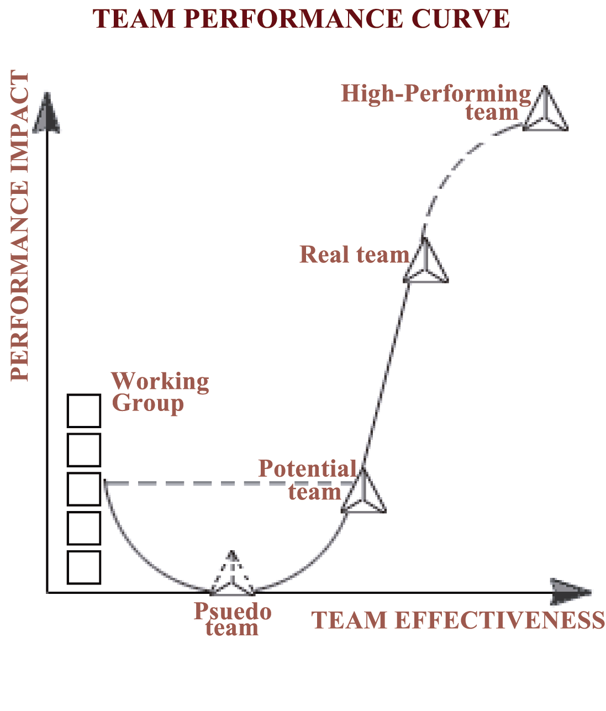
"I learned that the synergy of a group of people provides a product that is better than any individual effort."
"Prior teaming experiences taught me that in order for a team to function, the team was to be one that moves, plays, and cries together."
"I learned to listen to everyone's opinion because they may have a solution."
Foundation Coalition Students
* Complementary skills in industry often refer to functional roles, e.g., engineering, finance, manufacturing, and sales. In school, students bring different backgrounds (urban/rural, etc.), abilities, and styles.

How might I develop interpersonal and team skills?
- Students will not necessarily develop team skills by working in groups.
- Invest small amounts of class time in improving listening, decision-making, conflict resolution, constructive feedback, and meeting skills as well as increasing their knowledge about team dynamics, e.g., five stages of team development: forming, storming, norming, performing, and adjourning.⁹

How might I design exercises for student teams?
- Design team exercises that will require contributions from everyone. Avoid exercises that most people in the class could do on their own.
How might I assign individual grades for team projects?
Giving every individual the same grade for a team assignment runs counter to the principle of individual accountability in cooperative learning. Further, it may reward and even encourage "hitchhiking" by some members of a team. However, determining individual grades for work products submitted by a team is a challenging task. One approach to obtain information that may be helpful in determining individual grades is peer assessment, i.e., allow team members to assess the other members of the team, and perhaps themselves. As a purely quantitative example, Rob Brown developed an autorating system.¹⁰ Each team member provides an overall rating for every member of the team. With the ratings the teacher calculates "a weighing factor for each student. This weighing factor is multiplied" by the team grade assigned by the instructor to obtain the grade for an individual. Faculty at NC State used a variation of the autorating system in two chemical engineering classes to examine the validity of concerns about peer ratings. "The results suggest that the autorating system works exceptionally well as a rule, and the benefits it provides more than compensate for the relatively infrequent problems that may occur in its use."¹¹ Instead of soliciting a single summative response from each team member, other instructors ask for evaluation of multiple attributes. Kaufman et. al. suggest that providing a more detailed rubric to the students for assessment of their peers may increase the effectiveness of the peer rating process.¹¹ However, students often will return nearly uniform responses unless you provide them with guidelines and suggestions on completing your peer assessment form. By allowing students to participate, peer assessment can build a sense of ownership, commitment, and responsibility in team members.

References for Further Information
- Katzenbach, Jon R. and Douglas K. Smith, Wisdom of Teams, Harvard Business School Press, 1992
- Seat, E. and S. Lord, "Enabling Effective Engineering Teams: A Program for Teaching Interaction Skills," J. Engr. Ed., 88(4), Oct 1999, pp. 385-390
- “Engineering Education for a Changing World,” Report prepared by the ASEE Engineering Deans' Council and Corporate Roundtable, Washington, D.C., ASEE, 1994.
- ASTD, "Workplace Basics: The Skills Employers Want," American Society for Training and Development and U. S. Department of Labor, Employment and Training Administration, 1988.
- Evans, D. L., G. C. Beakley, P. E. Crouch, and G. T. Yamaguchi, "Attributes of Engineering Graduates and Their Impact on Curriculum Design," J. Engr. Ed., 82(4), Oct 1993
- ABET, "ABET Engineering Criteria 2000," The Engineering Accreditation Commission, Accreditation Board for Engineering and Technology, Inc.
- Johnson, D. W., R. T. Johnson, and Edythe Johnson Holubec, Circles of Learning: Cooperation in the Classroom, revised edition, Edina, MN: Interaction Book Company, 1986.
- Haag, S.G., "Teaming Backlash: Reframing Female Engineering Students," Proceedings, 2000 ASEE Conference, St. Louis, MI, June 18-21, 2000 http://www.asee.org/conferences/search/20618.pdf
- W. Tuckman & M.A.C. Jensen, "Stages of Small-Group Development Revisited," Group & Organization Studies, 2(4), December 1977, pp. 419-427
- Brown, R. W., "Autorating: Getting Individual Marks from Team Marks and Enhancing Teamwork," Proceedings, 1995 Frontiers in Education Conference http://fie.engrng.pitt.edu/fie95/3c2/3c24/3c24.htm
- Kaufman, D. B., R. M. Felder, H. Fuller, "Accounting for Individual Effort in Cooperative Learning Teams," J. Engr. Ed., 89(2), 133–140 (2000) http://www2.ncsu.edu/unity/lockers/users/f/felder/public/Papers/Kaufmanpap.pdf
Whether you're just getting started or looking for some additional ideas, the Foundation Coalition would like to help you incorporate student teams into your engineering classes through workshops, web sites, lesson plans, and reading materials. For suggestions on where to start, see our web site at http://www.foundationcoalition.org or contact: Jeffrey Froyd at froyd@ee.tamu.edu or 979-845-7574.

How might I assign students to teams?
- Teachers should assign teams instead of letting students choose their own. Teachers may survey students regarding preferences, schedules, and residences to gather info that can aid in the assignment.
- Without additional information, it is preferable to increase heterogeneity in terms of academic and other abilities.
- Without additional information, it is preferable to avoid having a single representative of either gender or an underrepresented minority on a team. (For a different perspective see [8].)

How might I facilitate dysfunctional teams?
- Help team members accept responsibility for successful development of the team. It is preferable that teachers facilitate with the entire team present.
- Encourage each team member to state what he/she has done, not his/her perception of what others have done. Encourage constructive feedback.
- Reduce likelihood and severity of dysfunctional teams by periodically monitoring progress and effectiveness. For example, weekly ask teams how well they are meeting their goals, how well they are working together, how much time they are spending, and if there are individual problems.

