Facilitating Dysfunctional Teams
http://www.foundationcoalition.org

Definition
A team is a small group of people with complementary skills who are committed to a common purpose, performance goals, and approach for which they hold themselves mutually accountable.¹ Although student teams may not satisfy all the requirements of the definition, the degree to which they do often determines their effectiveness.

Rationale
"Students do not come to school with the social skills they need to collaborate effectively with others. So teachers need to teach the appropriate communication, leadership, trust, decision making, and conflict management skills to students and provide the motivation to use these skills in order for groups to function effectively."² Faculty must take responsibility to help students develop their skills to participate on and lead teams.

Introduction
One of the more common questions that faculty members raise in Foundation Coalition workshops on student teams is what to do about dysfunctional teams. In an effort to provide constructive responses to this question, faculty members across the Foundation Coalition have assembled this document that addresses the following questions.
- What is a dysfunctional team and what behaviors might cause this?
- How might an instructor recognize a dysfunctional team?
- How might an instructor reduce the likelihood of dysfunctional teams?
- How might team members reduce the likelihood of dysfunctional teams?
- How might an instructor facilitate a dysfunctional team?
- What are examples of faculty members facilitating dysfunctional teams?

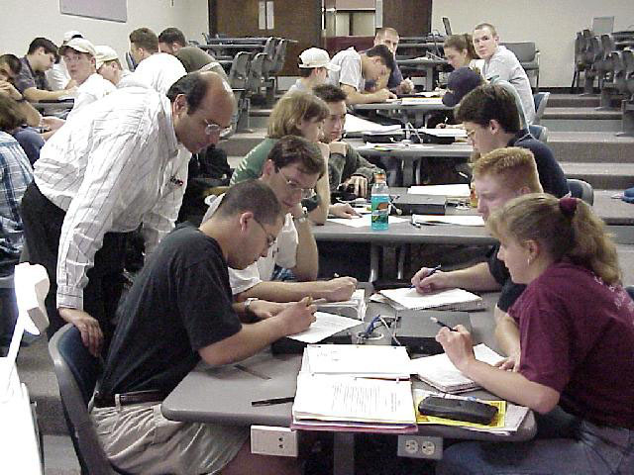

What is a dysfunctional team and what behaviors might cause this?
A dysfunctional team is a group in which the members do not work effectively together toward a common goal. Sometimes a dysfunctional team may not have constructed a common goal. In other cases, one or more team members DO NOT
- Contribute toward the goal
- Support other team members in achieving the goal
- Realize that they must work together in order to achieve the goal
- Feel a sense of commitment to one another
- Have a sense of interdependence

Examples of dysfunctional behaviors that might lead to the destruction of a team include¹
- Dominating the group, personally attacking other members, being overly aggressive
- Refusing to compromise, no matter what
- Polarizing discussions, creating win-lose alternatives
- Introducing or arguing for ideas related to personal interests, biases, or feelings
- Disrupting discussions or work sessions with clowning, joking, or other behaviors that interfere with the concentration of the team (as distinct from appropriate and even helpful amounts of spirited good humor that can be very constructive in maintaining team morale and energy), excessive side conversations
• Withdrawing, acting indifferent or passive about participation in the team, and letting others carry the load
- Promising results and not delivering

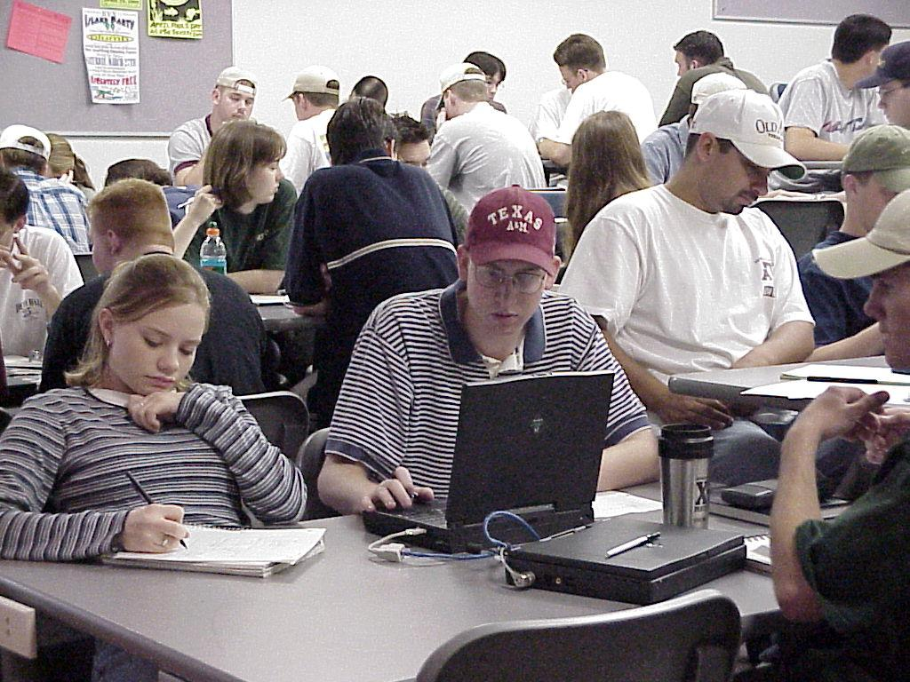

How might an instructor recognize a dysfunctional team?
- A student reports problems in the team or with team members
- A student has a friend on a team that is having problems
- Not turning in assignments
- Not meeting together
- Not discussing ideas in class
- Not showing up for class
- Breaking off into subgroups or cliques
- Negative feedback from one or more members of the team
- A subset of the team, perhaps only one member, seems to be doing the work.
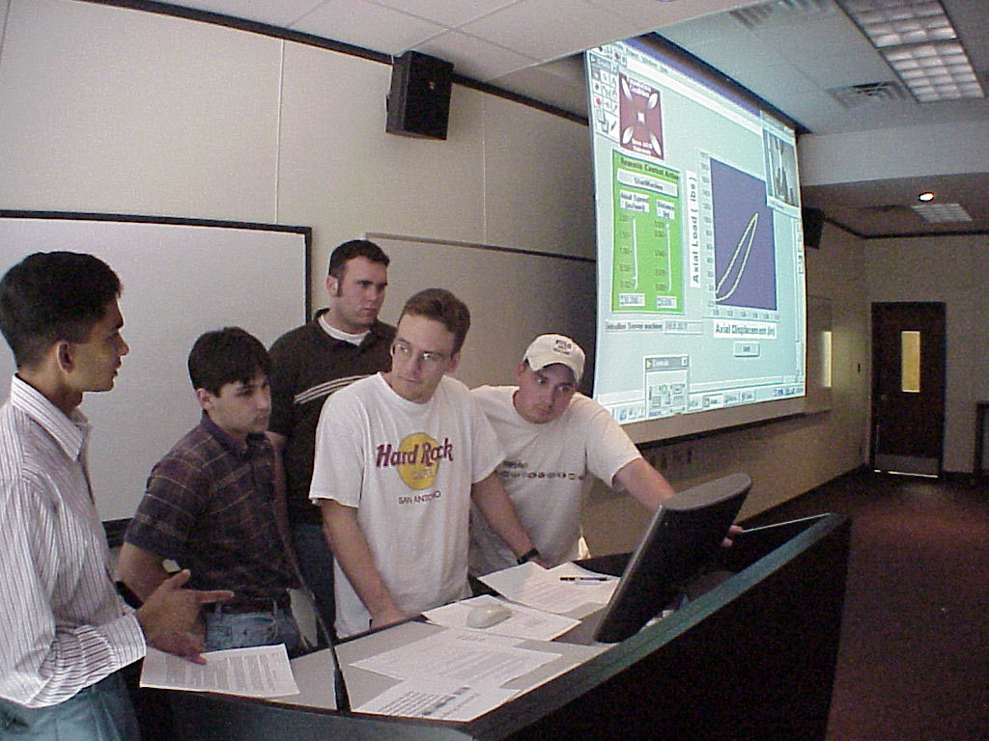

PREVENTION OF PROBLEMS IS THE BEST WAY FOR A PROFESSOR TO HELP TEAMS

How might an instructor reduce the likelihood of dysfunctional teams?
Investing time in helping teams get off to a good start can reduce the likelihood of dysfunctional teams, reduce the severity of dysfunction, and provide the foundation for facilitating dysfunctional teams. Here are some concrete suggestions.
- Provide training to the students about how to work in teams (confronting unrealistic expectations, diversity training, a system for managing conflict). See other documents in the series on team training.
- Plan the team assignments
- Assign the teams in a fair and careful manner
- Help team members develop a code of cooperation and a system for managing conflict
- Help team members anticipate possible dysfunctional behaviors and brainstorm about what
to do if these should occur
- Help team members accept responsibility for successful development of the team
- Periodically monitor progress and effectiveness before problems escalate
- Provide assessments of teams and team members with feedback
- Build both individual and collaborative responsibility (accountability) into the grading process

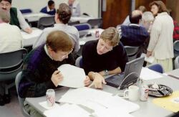

How might team members reduce the likelihood of dysfunctional teams?²
- Decide on a set of common goals.
- Get to know each other—foster team bonding, establish a team identity
- Establish some ground rules, e.g., code of cooperation, that outline acceptable means of interaction, conduct, and performance
- Define each member’s role
- Handle tough issues together
- Develop some common values
- Complement one another
- Get help

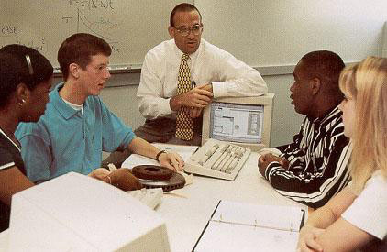

How might an instructor facilitate a dysfunctional team?
Ultimately, decisions to change what the team is doing and actions to improve future performance must be made by the team. An instructor can help a team recognize its challenges and
- Facilitate dialogue with the entire team present
- Ask team members to review or describe the goals for the team
- Ask team members to review their code of cooperation and explore what items are not
being followed
- Instructor leads a review list of effective team traits
- Each member should review each trait and decide where it is not working
- Group comes together to discuss what traits are missing
- Ask team members to suggest strategies to address their problems
- Openly confront the difference or discuss where the difficulty lies. As a group, define the issue (not the person) at hand. Use constructive feedback
- Decide on solutions that will be employed to address the problem
- Discuss where the team is now and where it needs to be
- Define the problem that is keeping the team from moving ahead
- Discuss all possible solutions (to be conducted by instructor)
- Negotiate openly with the group
- Ask team members to suggest strategies to address their problems
- Meet again with the group and reestablish team expectations, goals, and behaviors
- Meet with team members individually to uncover their needs and how the team can meet those needs
- Increase positive reinforcement
- If problem continues, confront person privately again about the person’s behavior
- Listen to the problem from the team, not just individuals. Paraphrase and summarize what they are saying, without lecturing
- If nothing changes, the person must be taken out of the group. This possibility should be raised at the beginning (very important point) of a team assignment
Many dysfunctional teams can be improved by open discussion with the team. Occasionally, an outside person can help the team resolve the problem. Very rarely, problems are so severe that the team needs to be dissolved or a team member needs to leave the group.³

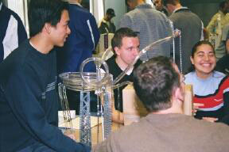

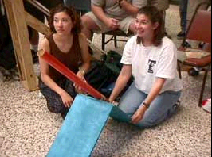

What are examples of faculty members facilitating dysfunctional teams?
Although the principles and suggestions described above may be very helpful to faculty members who are confronted with dysfunctional teams, some may raise questions about how the principles and suggestions may be applied in more concrete situations. Many faculty members throughout the Foundation Coalition have been using student teams in their classes for several years. Each has developed her or his own approach to facilitating dysfunctional teams, partly based on published research and partly based on her or his experience. Hopefully, actual examples of how some faculty members facilitate dysfunctional teams in their classes will help others.

Example 1: Jim Morgan, Texas A&M University
Jim Morgan (Jim-morgan@tamu.edu) often teaches first-year engineering courses in section sizes of one hundred. He uses the following steps for facilitating a dysfunctional team:
- Set up a team meeting. Do not discuss the problem with individual members of the team.
- Ask the team to bring their (individual and team) goals and code of cooperation to the meeting.
- Review the two documents with the team and ask questions until the students start to engage each other in a discussion.
- Sit back to watch the team resolve the conflict(s).
A common scenario:
First student “Everyone knows we are all here to get an A!”
Second student “All I want to do is to survive and have a good time.”
Faculty member “How hard would you be working if it were not for the team?”
Both students “Oh . . . .”
Both students had assumed that they had the same goals and that the other student was the one with unreasonable demands or commitment. Now they decide that it is their individual goals that caused the conflict and realize that, with or without teams, they would be doing about the same amount of work (and with peer evaluation getting the grade that they are individually shooting for).

Example 2: P.K. Imbrie, Purdue University
P. K. Imbrie (imbrie@purdue.edu) teaches first-year engineering classes at Purdue University. Section sizes for first-year engineering classes range from 180 to 475 students. He uses the following technique in these large first-year engineering classes for providing teams with self reflection and group processing (including self facilitation).
- Each individual submits regular (Web-based) reflection reports.
How have I done as a team member?
What could I have done to help my team more?
How have others on my team done as team members?
What could they have done to help my team more?
How have we done as a team?

- Each individual has previously submitted reflection reports, such as:
How did I do on exam one?
What could I have done to improve my performance?
How did we do on the last team assignment?
What could we have done to improve performance?

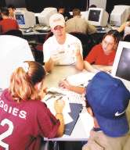
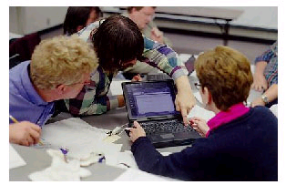
The Web provides a convenient way of collecting and processing information from a large number of students, and teams that need special or individual attention can be quickly identified.

Example 3: Russ Pimmel, University of Alabama
Russ Pimmel (rpimmel@coe.eng.ua.edu) teaches the senior/junior course in computer engineering with extended projects.
“By reviewing the weekly progress reports (short multiple-choice surveys of progress, effort, and cooperation), I can identify teams with problems. If I have determined that a team has a problem, then I ask them to see me either before or after class for a very brief meeting in which I determine if they have resolved their problem and have made some adjustments (usually the case) or need further attention. If the problem results from a noncontributor, then I reassure them that slacker will get no credit unless he or she gets involved. I then try meet privately with the individual to point out the penalties for not contributing and to encourage him or her to become a player. If the problem is deeper, I try to draw them out and get them to clarify the difficulty and to identify approaches for dealing with it. I usually check with them a few days later and pay special attention to their next progress report.”

Suggestions for Further Reading
Katzenbach, J.R., and Smith, D.K., 1992, Wisdom of Teams, Harvard Business School Press.
Johnson, D.W., Johnson, R.T., and Holubec, Edythe Johnson, 1986, Circles of Learning: Cooperation in the Classroom, rev. ed., Edina, MN: Interaction Book Company.
Busseri, Michael, and Palmer, Jason, 2000, “Improving teamwork: the effect of self-assessment on construction design teams,” Design Studies 21:223–238.
Dee, Jay, and Henkin, Alan,1998–99, “Collaborative learning, communication and student outcomes in higher education: assessing verbal interaction,” J. Staff, Program and Organization Development, vol. 16:3, pp. 125–134.
Dumaine, Brian, 1994, “The trouble with teams,” Fortune, vol. 130:5, p. 86 (5).
Hoevemeyer, Victoria, 1993, “How effective is your team?”, Training and Development, pp. 67–71.
Kalliath, Thomas, 1999, “Teaching team effectiveness in an O.D. course,” Organization Development J., vol. 17:3, pp. 39–48.
Kline, Theresa, 1999, “The Team Player Inventory: reliability and validity of a measure of predisposition toward organizational team-working environments,” J. Specialists in Group Work, vol. 24:1, pp. 102–112.
Levi, Daniel, and Cadiz, David, 1998, “Evaluating team work on student projects: the use of behaviorally anchored scales to evaluate student performance.”
Parker, G.M., 1990, Team Players and Teamwork: The New Competitive Business Strategy, Jossey-Bass Inc.: CA.
Paris, Carol, Salar, Eduardo, and Cannon-Bowers, Janis, 2000, “Teamwork in multi-person systems: a review and analysis,” Ergonomics, vol. 43:8, 1052–1075.
Slavin, Robert, 1996, “Research on cooperative learning and achievement: what we know, what we need to know,” Contemporary Educational Psychology 21, pp. 43–69.
Springer, Leonard, Stanne, Mary Elizabeth, and Donovan, Samuel, 1999, “Effects of small-group learning on undergraduates in science, mathematics, engineering and technology: a meta-analysis,” Rev. Educational Research, vol. 69:1, pp. 21–51.
Tjosvold, D., 1986, Working Together to Get Things Done, Lexington Books: MA.
Trimble, Susan, and Rottier, Jerry, 1998, “Assessing team performance.”
Valkenbury, Rianne, and Dorst, Kees, 1998, “The reflective practice of design teams,” Design Studies 19:249–271.
Walker, Charles, and Angelo, Thomas, 1998, “A collective effort classroom assessment technique: promoting high performance in student teams,” New Directions for Teaching and Learning, no. 75, pp. 101–112.

Whether you're just getting started or looking for some additional ideas, the Foundation Coalition would like to help you incorporate student teams into your engineering classes through workshops, web sites, lesson plans, and reading materials. For suggestions on where to start, see our web site at
http://www.foundationcoalition.org or contact: Jeffrey Froyd at froyd@ee.tamu.edu or 979-845-7574.

