First-Year Engineering at Texas A&M University
http://www.foundationcoalition.org

Student Quotes
" We were so comfortable learning through technology that it helped with all my team projects, even after I left the first-year classroom."
EE student
"I enjoyed the integration of subjects because I enjoy seeing the big picture. I really need to see the big picture to understand things."
ME student
" We became concerned with how the team performed as individuals. The team was only as strong as the weakest individual."
EE student
“I liked learning about and working on technical problems that are occurring right now in industry and that are exciting to students.”
First-year engineering student

The first year engineering program at Texas A&M consists of clusters of 96 students who take courses (including chemistry, engineering, math and physics) together, and study together.

1800 Entering Students |  |  |  | Calc II+ | Linked | In the linked tracks, students are enrolled in common sections of two or more of the following: Engineering, Calculus, Physics, English. In independent tracks, students enroll in independent sections of their first-year courses.  (3%)
1800 Entering Students |  |  |  | Calc II+ | Independent | (14%)
1800 Entering Students |  |  | Calc I | Linked | (47%)
1800 Entering Students |  |  | Calc I | Independent | (8%)
1800 Entering Students |  | Pre-Calc Alg & Trig | Linked | (17%)
1800 Entering Students |  | Pre-Calc Alg & Trig | Independent | (11%)

Students enter a pre-calculus, calculus I, or calculus II+ track based on their academic preparation. Within these tracks students select either independent or clustered courses. All courses (linked or not) use a common synchronized syllabus (modified on an annual basis by faculty from each of the courses). Synchronization allows engineering faculty to build on topics covered in the other courses when they are being covered. Faculty in math and science often enhance this integration of material.
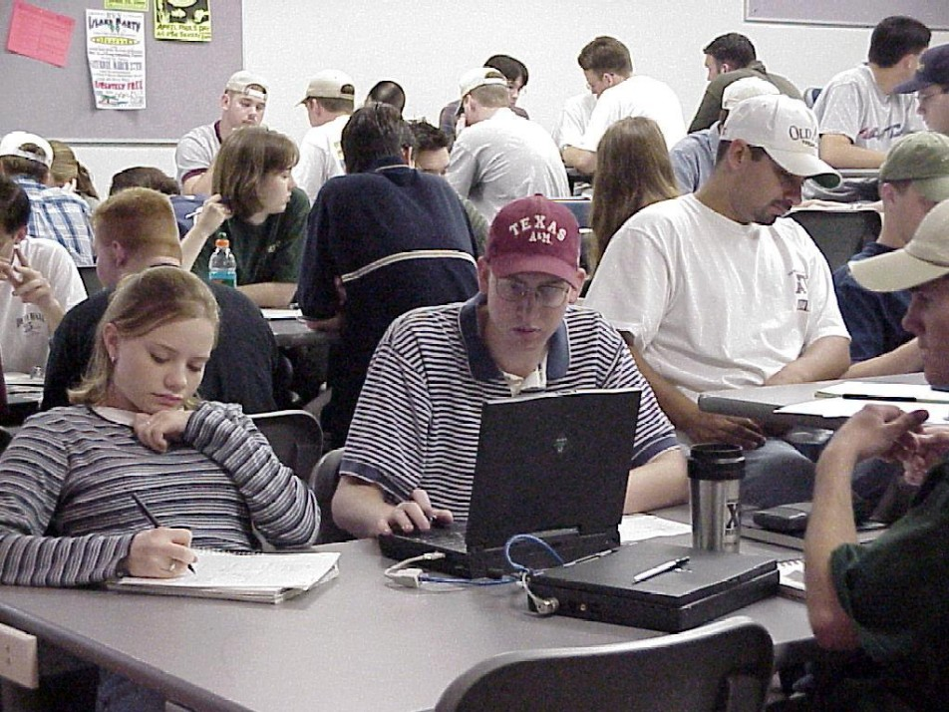
This new curriculum was based on a four-year pilot program that integrated calculus, physics, introduction to engineering and English.¹⁻⁵ Although the new curriculum is less tightly integrated than the pilot, it is being offered to all entering students so that they receive most of the benefits of the pilot program. Students take their introduction to engineering courses in innovative classrooms that provide access to computer technology. First-year faculty members encourage students to work in teams and use cooperative learning.
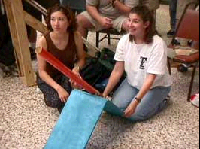
Does it Work?
The new curriculum has many advantages over the old, including the new integrated two-semester engineering sequence. This new course replaces stand-alone courses in engineering graphics and in engineering problem solving and computing. Because the stand-alone courses could be taken in any order, integration of material among them and other courses the students might be taking was impossible. This is no longer true!
Example 1: Students complete more credit hours toward an engineering degree completed with an A, B, or C grade during first year.
As shown in the figure above, students in the new, clustered technology-rich engineering curriculum make progress toward degree faster than students in non-clustered cohorts. Time to graduation also has been reduced approximately a semester since implementation of the new curriculum.

Example 3: Student performance is better on standardized tests and in follow-on courses in the new curriculum. The graph above compares performance on three nationally-normed instruments: Force Concept Inventory⁶ (FCI), Mechanics Baseline Test⁷ (MBT), and the Duke Calculus Concept Inventory.⁸ In 1996, the Foundation Coalition cohort performed better than a matched comparison group. Performance by the overall class in 1998 (when the new curriculum was implemented college-wide) was significantly better than either cohort in 1996.
Example 2: Retention is increased dramatically by the new engineering curriculum. Increases occur for all students, both women and men.
The graph above compares retention between a cohort of students who participated in the Foundation Coalition pilot curriculum with a carefully matched cohort of students who participated in the traditional curriculum. Retention for both male and female students in the Foundation Coalition cohort is significantly higher.
Example 4: In 1994, first-year retention for women was 3% lower than men while first-year retention for underrepresented minorities was 6% lower than non-minorities. In 1999, first-year retention for women and underrepresented minorities were 1% higher than male and non-minority retention, respectively.

FC Resources
Whether you're just getting started or looking for some additional ideas, the Foundation Coalition would like to help you with your first-year engineering students - through workshops, web sites, lesson plans, and reading materials. FC partner institutions have produced both written and electronic materials that address the issue of first-year engineering programs. Visit our web site at http://fountationcoalition.org/ • • • for online access to contact information and materials, or contact: Jeffrey Froyd at froyd@ee.tamu.edu or 979-845-7574.
Figure 1: Retention Data, New vs. Old Curriculum - Texas A&M

"We learned early on that engineering is not boxing in an answer on a chemistry problem. Engineering is using scientific tools to solve a problem." ME student
This allows them to complete more courses sooner (as in the graph above) and it means that more students graduate and graduate sooner as illustrated below.
Whether you're just getting started or looking for some additional ideas, the Foundation Coalition would like to help you improve integration across your engineering classes through workshops, web sites, lesson plans, and reading materials. For suggestions on where to start, see our web site at
http://www.foundationcoalition.org
or contact: Jeffrey Froyd at froyd@ee.tamu.edu or 979-845-7574.
References for Further Information:
- Bolton, B., and J. Morgan, “Engineering Graphics in an Integrated Environment,” Proceedings, 1997 Frontiers in Education Conference, ASEE/IEEE, Pittsburgh, Pennsylvania, November 1997
- Morgan, J., “A Freshman Engineering Experience,” Proceedings, 1997 ASEE Annual Conference, ASEE, 1997
- Morgan, J., “A Freshman Engineering Experience the Foundation Coalition at Texas A&M University,” Proceedings, Eighth 8th Annual TBEEC Conference on Learning With Technology, TBEEC, 1996
- Everett, L., et al., “An Integrated Freshman Engineering Curriculum, Why You Need It and How to Design It,” Proceedings, 1995 Frontiers in Education Conference, ASEE/IEEE, 1995
- Willson, V., T. Monogue, and C. Malave, “First Year Comparative Evaluation of the Texas A&M Freshman Integrated Engineering Program,” Proceedings, 1995 Frontiers in Education Conference, ASEE/IEEE, 1995
- Hestenes, D., M. Wells, and G. Swackhamer, Force Concept Inventory, The Physics Teacher, 30: 141-158 (1992)
- Hestenes, D., and M. Wells, A Mechanics Baseline Test, The Physics Teacher, 30: 159-165 (1992)
- The Duke Calculus Test was adapted from a test developed by Jack Bookman at Duke University for use with their NSF-supported Calculus Reform project.
"We learned early on that engineering is not boxing in an answer on a chemistry problem. Engineering is using scientific tools to solve a problem." ME student

